**Project Report**

**Course**: CO2214: Practical Work on CO2224  
**Group Name/Number**: Group Name - 9  
**Student IDs**:

* EUSL/TC/IS/2021/COM/10
* EUSL/TC/IS/2021/COM/62
* EUSL/TC/IS/2021/COM/50
* EUSL/TC/IS/2021/COM/89
* EUSL/TC/IS/2021/COM/92
* EUSL/TC/IS/2020/COM/106

**1. Project Overview**

* **Project Title**: Modify UI of the Sri Lankan Railway Website for Mobile
* **Project Type**: Website
* **Domain**: Transportation
* **Brief Description**: Enhance the mobile usability of the Sri Lankan Railway website by redesigning its user interface to be more responsive and user-friendly.
* **Target Users**: General public of Sri Lanka

**2. Identification of Existing Design Flaws & Gaps**

### 2.1 Evaluation Criteria (HCI Issues)

1. **Small and Unreadable Text**
   * **Problem: Text that is too small or poorly designed can lead to accessibility issues, especially for users with visual impairments or those using devices with smaller screens.**
   * **Impact: This creates a barrier to effective communication, reducing user comprehension and overall experience.**
   * **Possible Solutions:**
     + **Use scalable and legible font sizes, adhering to web accessibility standards (e.g., WCAG guidelines).**
     + **Allow users to adjust text size according to personal preference.**
2. **Poor Alignment and Inconsistent Spacing**
   * **Problem: Misalignment of text, images, and other content elements, along with inconsistent spacing, can make a user interface (UI) feel disorganized and difficult to navigate.**
   * **Impact: This detracts from the visual appeal and usability of the interface, leading to confusion and potential frustration for users.**
   * **Possible Solutions:**
     + **Apply grid systems or design frameworks to ensure consistent alignment.**
     + **Maintain uniform margins and padding to improve the readability and flow of information.**
3. **Non-Responsive Layout Leading to Content Overflow**
   * **Problem: A layout that doesn't adapt properly to different screen sizes or orientations may cause content to overflow, making it inaccessible or difficult to interact with on certain devices.**
   * **Impact: This hinders usability, particularly on mobile devices or smaller screens, and may result in content being cut off or hidden.**
   * **Possible Solutions:**
     + **Implement responsive design practices using CSS media queries to ensure the layout adjusts seamlessly across different devices and screen sizes.**
     + **Use flexible grids and relative units (e.g., percentages, ems) for better adaptability.**

**2.1 Usability Issues Identified**

* Small and unreadable text
* Poor alignment and inconsistent spacing
* Non-responsive layout leading to content overflow

**2.2 User Experience Problems**

* Complicated navigation structure
* No visual hierarchy in content
* Accessibility issues (low contrast, small touch areas)
  1. **Screenshots & Examples**

**Empty spaces on both sides of the screen; content is not full-width**

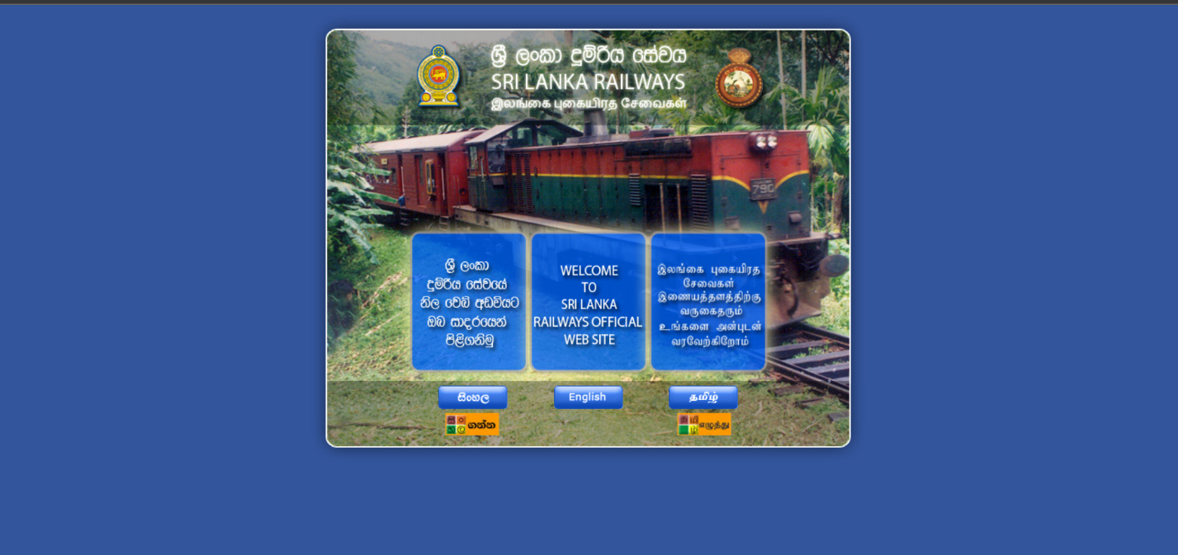

***Not suitable Links and Menus***



**No proper zoom in/out, and interaction is not intuitive**



**Search bar is too small and not prominently placed.**

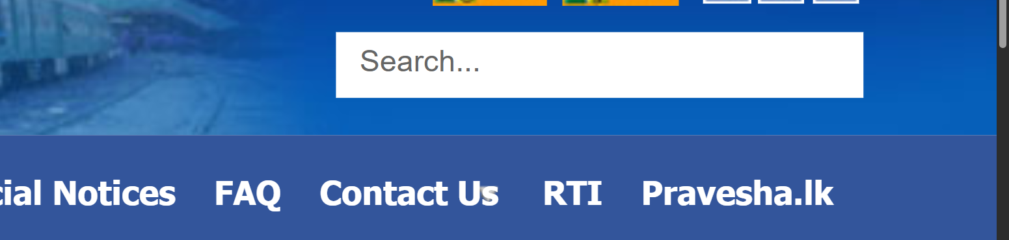

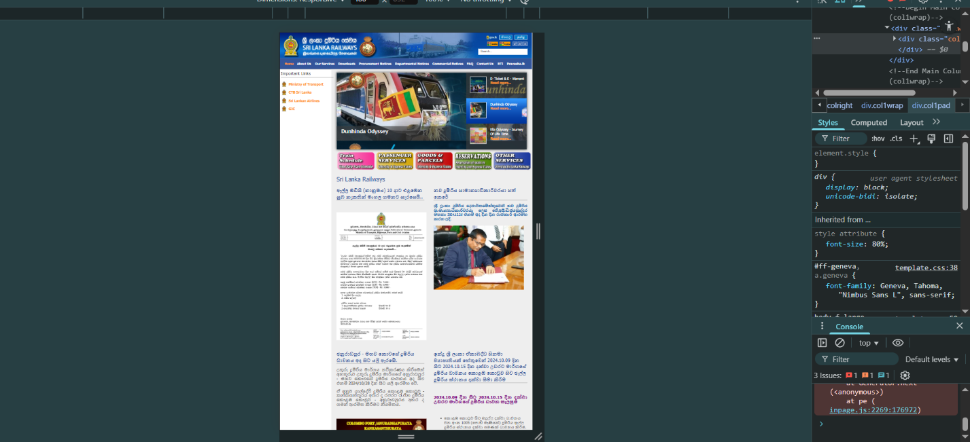

* **Map interface above Sri Lanka is not interactive and confusing.**

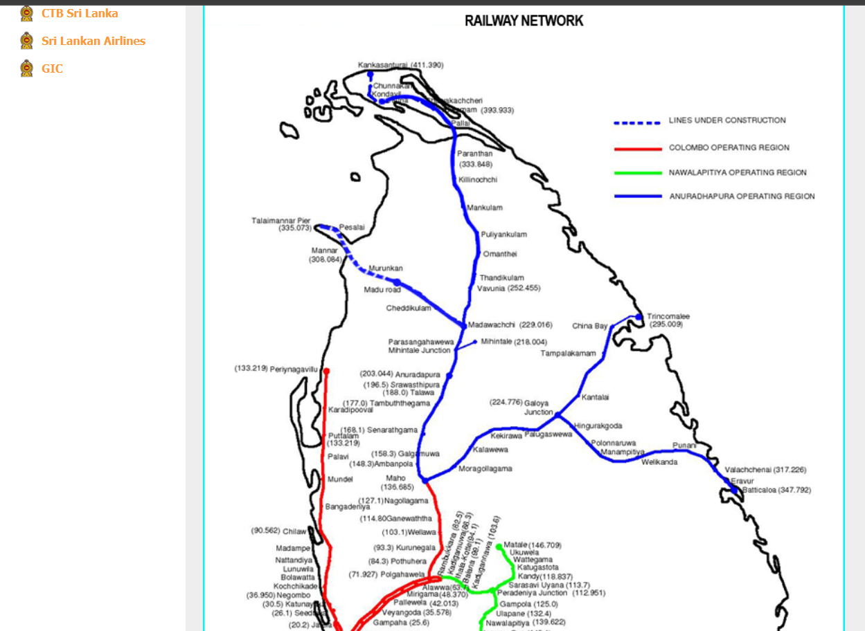

**No spacing between bullet points and inconsistent font sizes between Sinhala and English.**

